Program Information | [Lesson Title]  Fossil Fuel Debate |  |  |  |  | TEACHER NAME  Jessica Untch |  |  | PROGRAM NAME  Parma City School District
Program Information | [Unit Title]  Argument Writing |  |  |  |  | NRS EFL(s)  3 – 5 |  |  | TIME FRAME  120 – 150 minutes
Instruction | ABE/ASE Standards – English Language Arts and Literacy
Instruction | Reading (R) |  |  | Writing (W) |  | Speaking & Listening (S) |  | Language (L)
Instruction | Foundational Skills |  |  | Text Types and Purposes | W.3.1  W.4.1  W.5.1 | Comprehension and Collaboration | S.3.1  S.4.1  S.5.1 | Conventions of Standard English
Instruction | Key Ideas and Details |  |  | Production and Distribution of Writing | W.3.6 | Presentation of Knowledge and Ideas |  | Knowledge of Language
Instruction | Craft and Structure |  |  | Research to Build and Present Knowledge | W.4.6 |  |  | Vocabulary Acquisition and Use
Instruction | Integration of Knowledge and Ideas |  | R.4.12  R.5.9 |  |  |  |  | Benchmarks identified in RED are priority benchmarks. To view a complete list of priority benchmarks and related Ohio Aspire lesson plans, please see the Curriculum Alignments located on the Teacher Resource Center.
Instruction | LEARNER OUTCOME(S)  - Students will be able to evaluate an argument and specific claims in a text, assessing whether the reasoning is sound and the evidence is relevant and sufficient, and demonstrate this in a coherent essay.  - Students will be able to engage effectively in collaborative discussions (one-on-one, in groups, and teacher-led) and demonstrate the ability to express their ideas clearly. |  |  |  |  | ASSESSMENT TOOLS/METHODS  Formative:  - Assess the quality of student responses while discussing whether US should phase out fossil fuels.  Summative:  - Use rubric to grade student essays. Collect worksheets with questions regarding chart.

- Students will be able to write arguments to support claims with clear reasons and relevant evidence by producing a coherent essay.
- Students will be able to integrate quantitative or technical analysis (e.g., charts, research data) with qualitative analysis in print or digital text, and then answer questions on a worksheet with accuracy.
- Students will be able to conduct a short research project that builds knowledge about a topic by finding information online on the topic of fossil fuels.
LEARNER PRIOR KNOWLEDGE
- Familiarity with percentages.
- Ability to read charts and graphs.

 | INSTRUCTIONAL ACTIVITIES  - Explain the purpose of knowing how to defend a certain perspective and how it will be required on the RLA test. For the essay, test takers will be given 2 passages (for and against) and be required to choose a side and write an essay defending one of them. Today we will explore how to do that.  - Using laptop and projector go to http://alternativeenergy.procon.org/ and look at the core issue Alternative Energy v. Fossil Fuels.  - Explore the topic as a class, looking at the Chart of Energy Use by State and by Source. Point out how background information is categorized on the website (e.g. biomass, wind power, solar power, etc.). Next, distribute the Chart of Energy Use Questions handout (attached) with the following questions about the chart, allowing them to use their computers or tablets to locate information on the ProCon.org website:  - CA uses 8,420.4 BTU, which is 8.5% of the total used in the US. What, then, is the total used in the US?  - Which state relies most heavily on coal? Why?  - Which state relies most heavily on biomass? What is biomass?  - Which form of alternative energy is most widely used? (nuclear).  - How much did energy use (alternative v. fossil) change from 2003-2007? Did people rely more or less on alternative sources?  - Review answers together as a class.  - After exploring the core issue and background information, introduce the writing topic- Should the US immediately phase out fossil fuels? Read at least 2 opinions, one pro and one con, for example: Rainforest Action Network and Tom Pyle, President of the Institute for Energy Research. Discuss unfamiliar vocabulary words as they come up. Ask students to think about which perspective they would defend and have them state why. Pay | RESOURCES  Pens/pencils  Paper for student writing samples  Computer with projector, internet access, and sound/speakers  Computers and/or tablets with internet access and sound/speakers/headsets for students  ProCon.org: Alternative Energy Debate. (n.d.). Retrieved from  http://alternativeenergy.procon.org/  ProCon.org: Chart of Energy Use by State and by Source. (2006). Retrieved from http://alternativeenergy.procon.org/view.resource.php?resour ceID=001795  Student copies of Chart of Energy Use Questions (attached)  Selected readings from ProCon.org: Should the US Immediately Phase Out Fossil Fuels? (n.d.). Retrieved from http://alternativeenergy.procon.org/view.answers.php?questio nID=001350  Student copies of Extended Response Planner (attached)

 | attention to the quality of student responses and address any facts that may be inaccurate. Guide the discussion based on evidence from the articles and critical thinking techniques. Be sure that fracking is brought up - talk about the jobs created by fracking and the lower gas prices we are seeing as well as the concerns about contaminated drinking water. If students are very unfamiliar with the topic of fracking, it may be helpful to show one or two short videos- for example, Fracking Explained: Opportunity or Danger (5 minutes).  - Take a 15 minute break.  - When students return, ask for a show of hands to see which side of the argument had more supporters. Choose that perspective to demonstrate how to use the Extended Response Planner (attached) and outline an essay as a group. If students have trouble with the concept of citing evidence, present several examples from both articles and list them on the board for the students to note on their planners.  - Distribute the Essay Editing Checklist (attached) to students. Have students use their Extended Response Planner to write their individual essays. Give work time in class and allow use of computers for further research. Check-in with students as they are writing and provide guidance as needed.  - Collect both the completed Chart of Energy Use Questions and the student extended response drafts for review and comment prior to the next class period. Use the Writing Rubric (attached) to evaluate student writing samples. | Student copies of Argument Writing Graphic Organizer  (attached)  Student copies of Essay Editing Checklist (attached)  Writing Rubric (attached)  Fracking Explained: Opportunity or Danger video Gesagt, K. (2013, September 3). Retrieved from  https://www.youtube.com/watch?v=Uti2niW2BRA

DIFFERENTIATION

- Advanced students can conduct independent research, take notes, and write a more academic essay using evidence from multiple sources.
- Lower level students can use evidence from the two perspectives on ProCon.org only.
Reflection | TEACHER REFLECTION/LESSON EVALUATION  - Using the Extended Response Planner in class was a little cumbersome, so allow extra time. An alternative to the Extended Response Planner would be the Argument Writing Graphic Organizer (attached).
Reflection | ADDITIONAL INFORMATION  - Extension: when students feel comfortable, have them choose their own topic from ProCon.org and write an essay independently.

Chart of Energy Use Questions

“Chart of Energy Use by State and by Source, 2008”

- California uses 8,381.5 BTU of energy per year, which is 8.4% of the total used in the US. What, then, is the total used in the US?

- Which state relies most heavily on coal? Why do you think this is?

- Which state relies most heavily on biomass? What is biomass?

- Which form of alternative energy is most widely used in the U.S.?

- How much did energy use (alternative vs. fossil) change from 2003-2007? Did people rely more or less on alternative sources in 2007?

Extended Response Planner
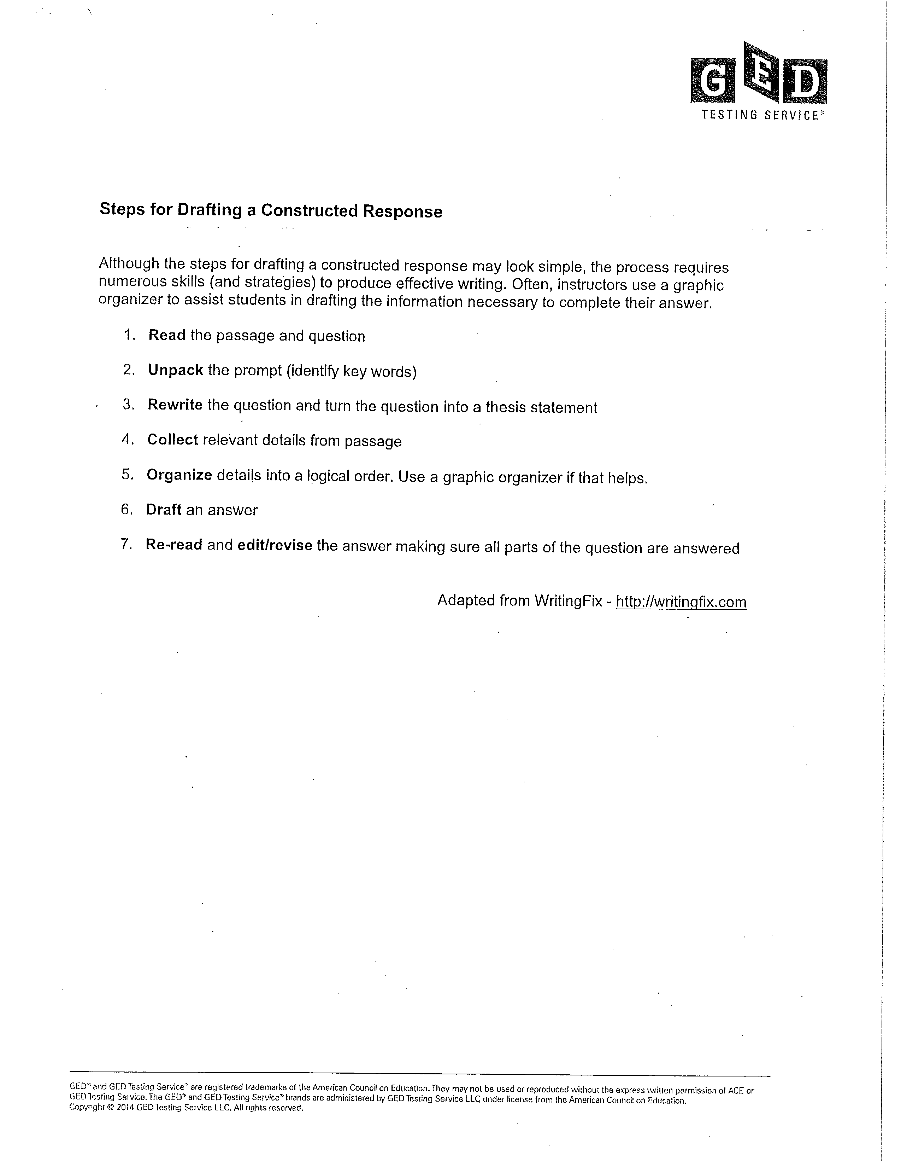

Extended Response Planner
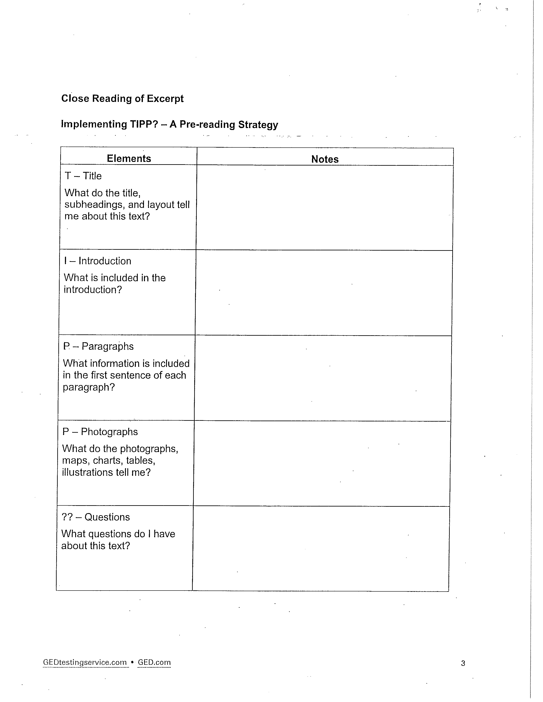

Extended Response Planner
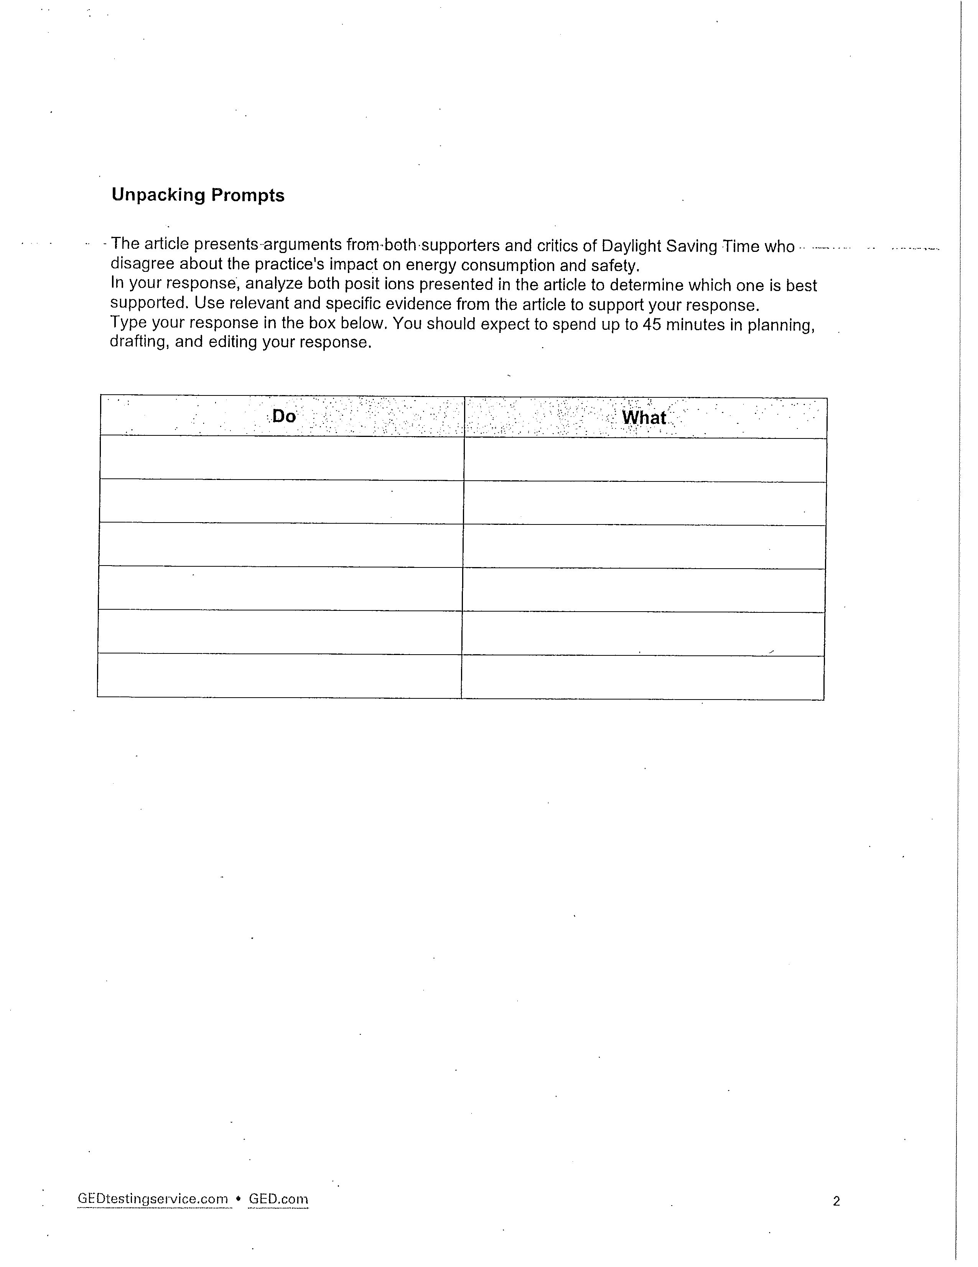

Extended Response Planner
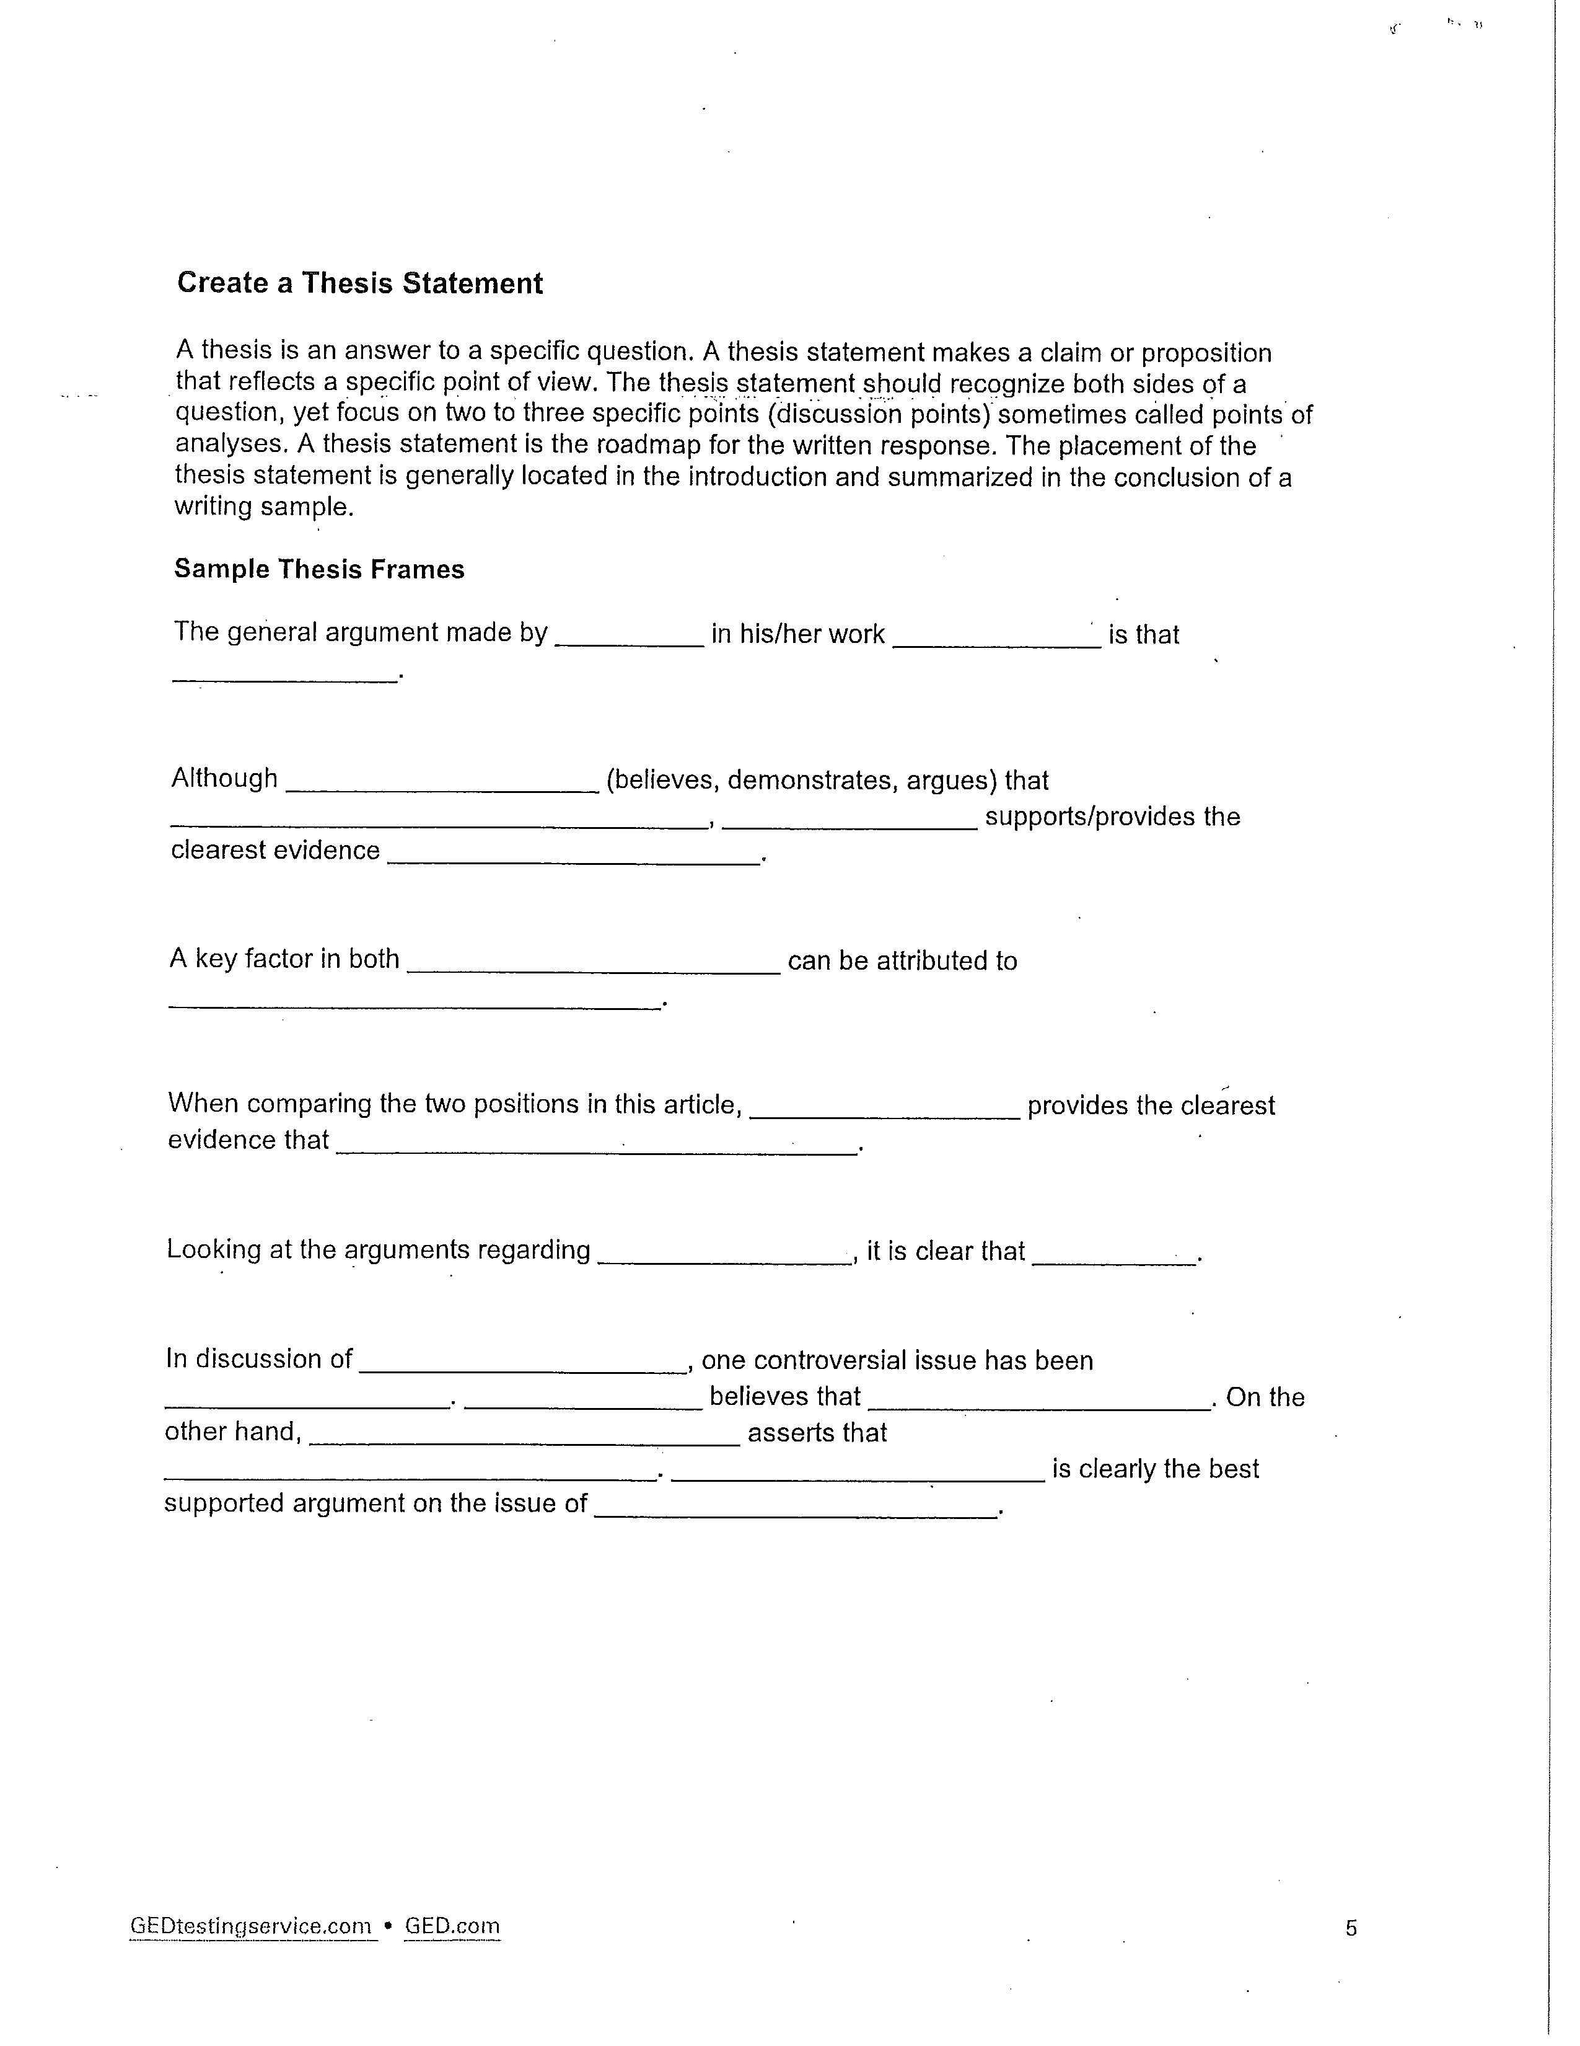

Extended Response Planner
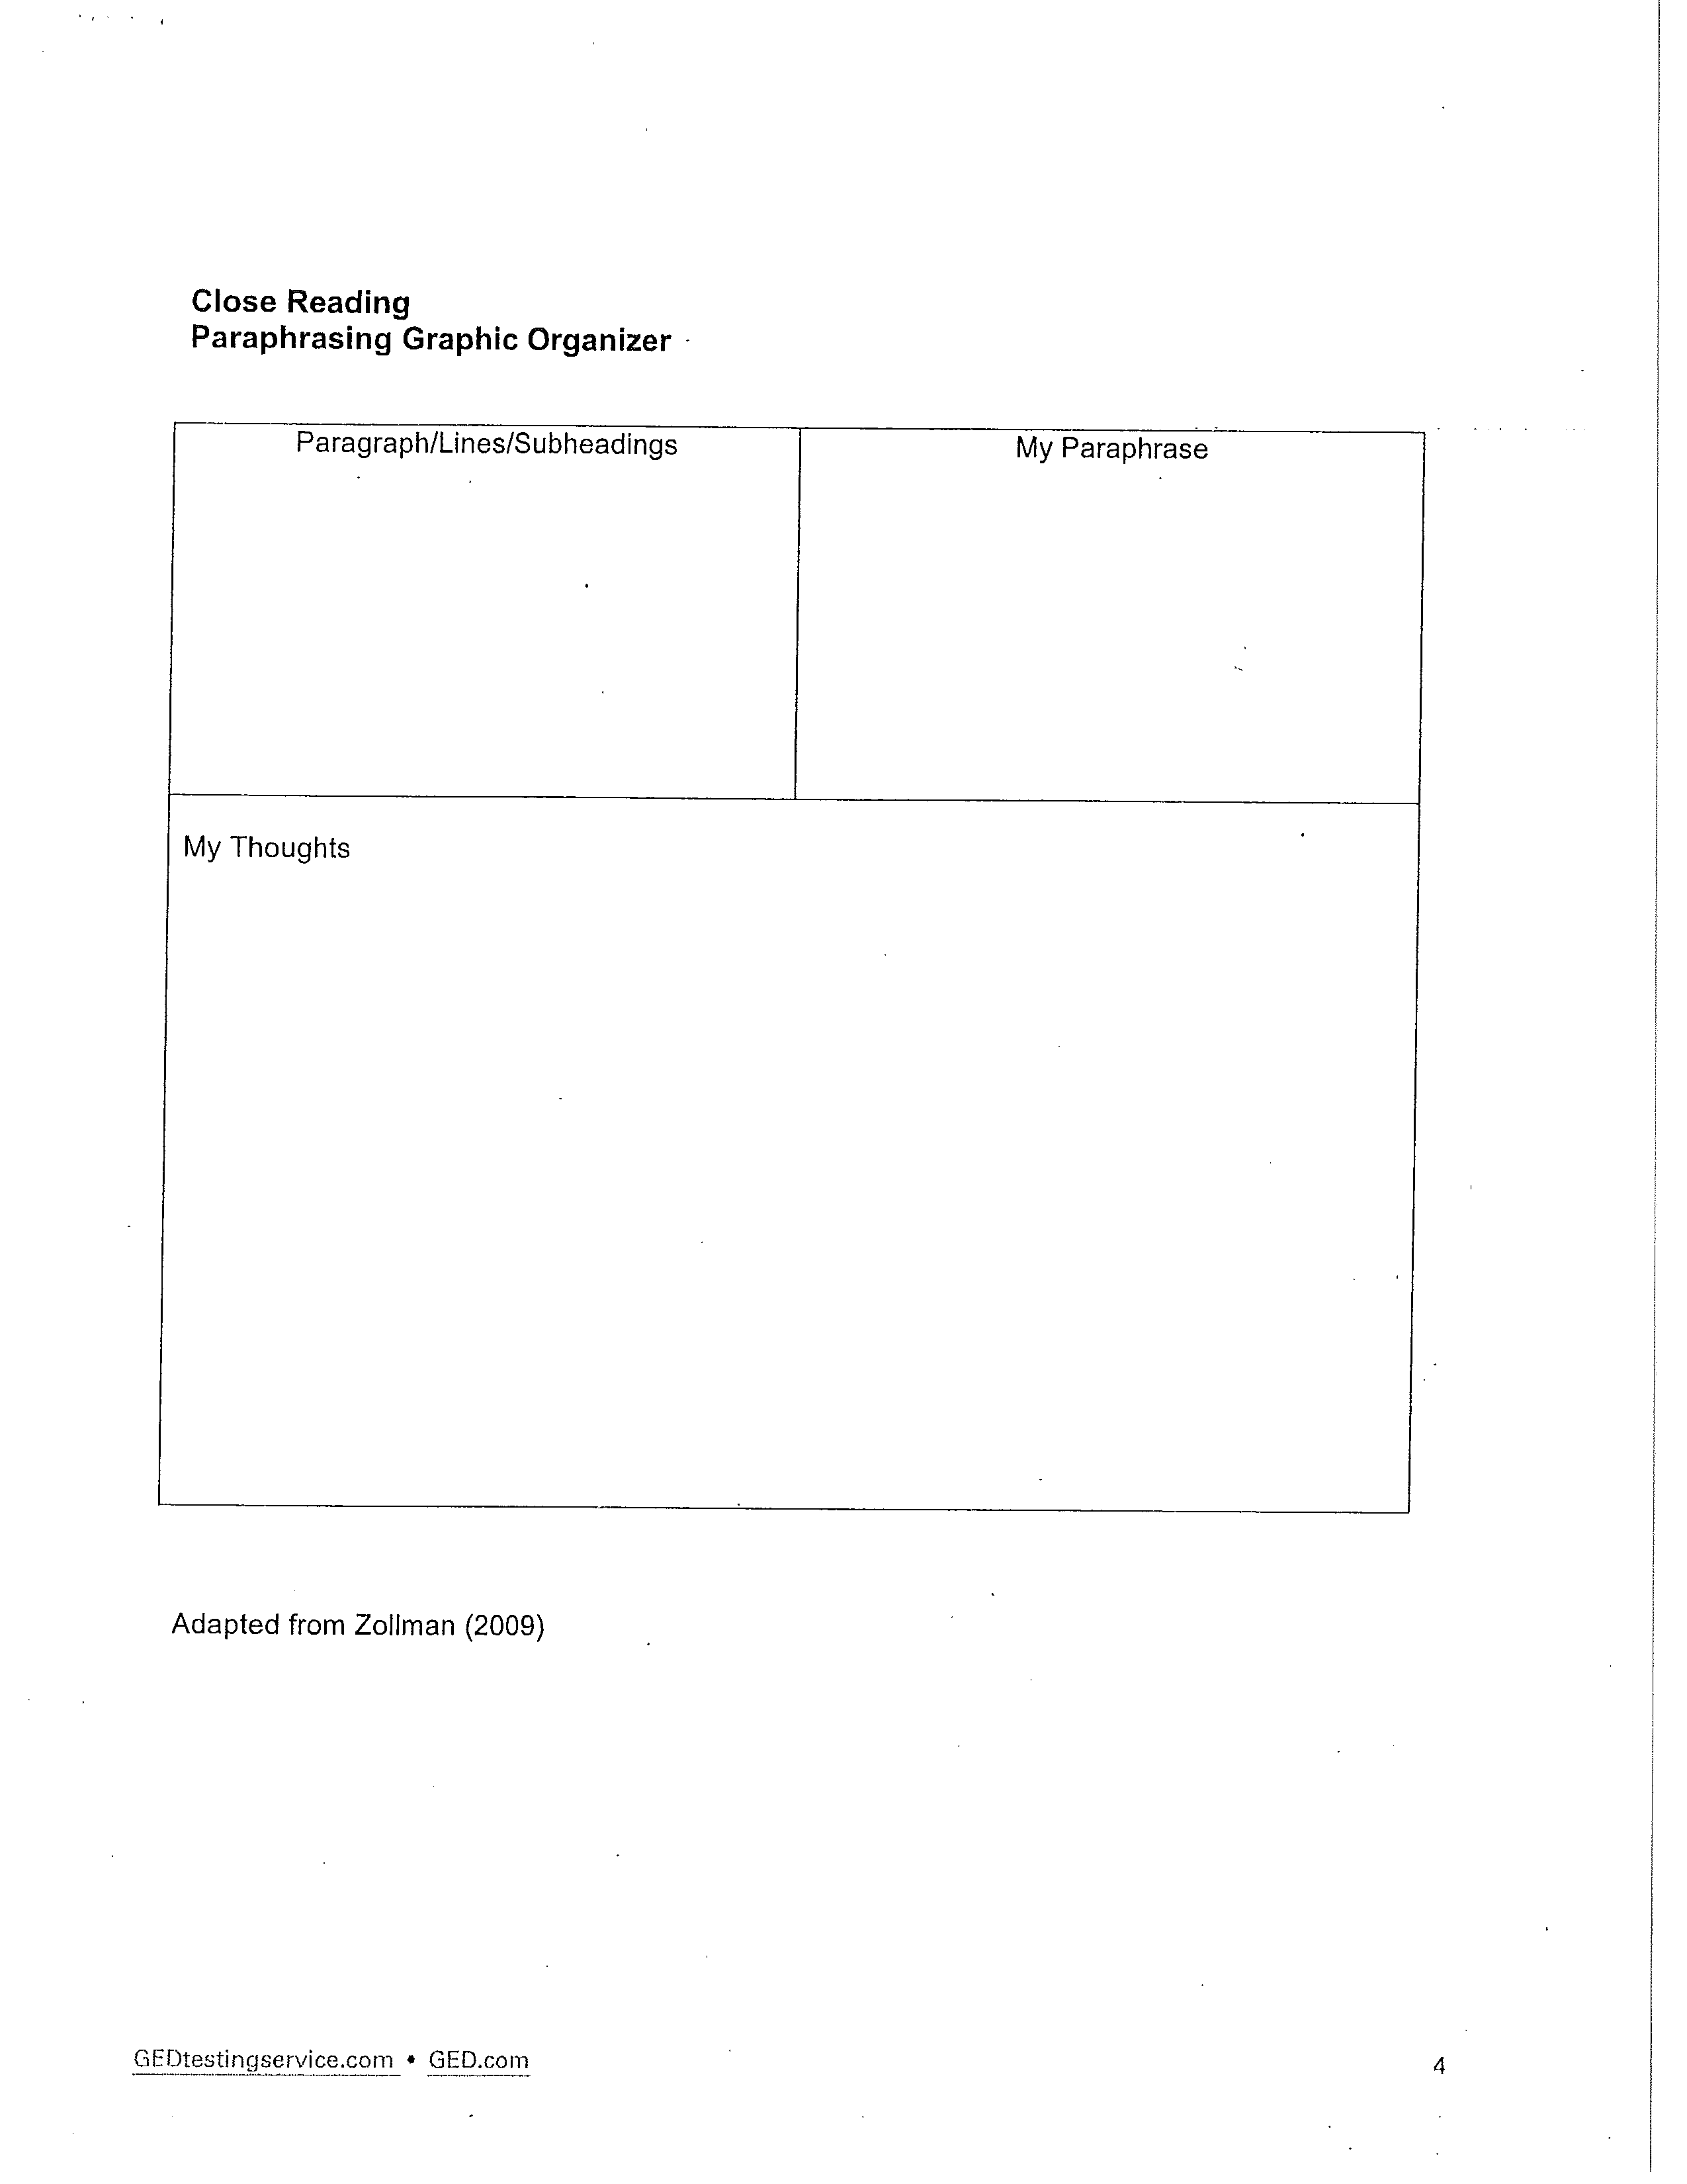

Extended Response Planner
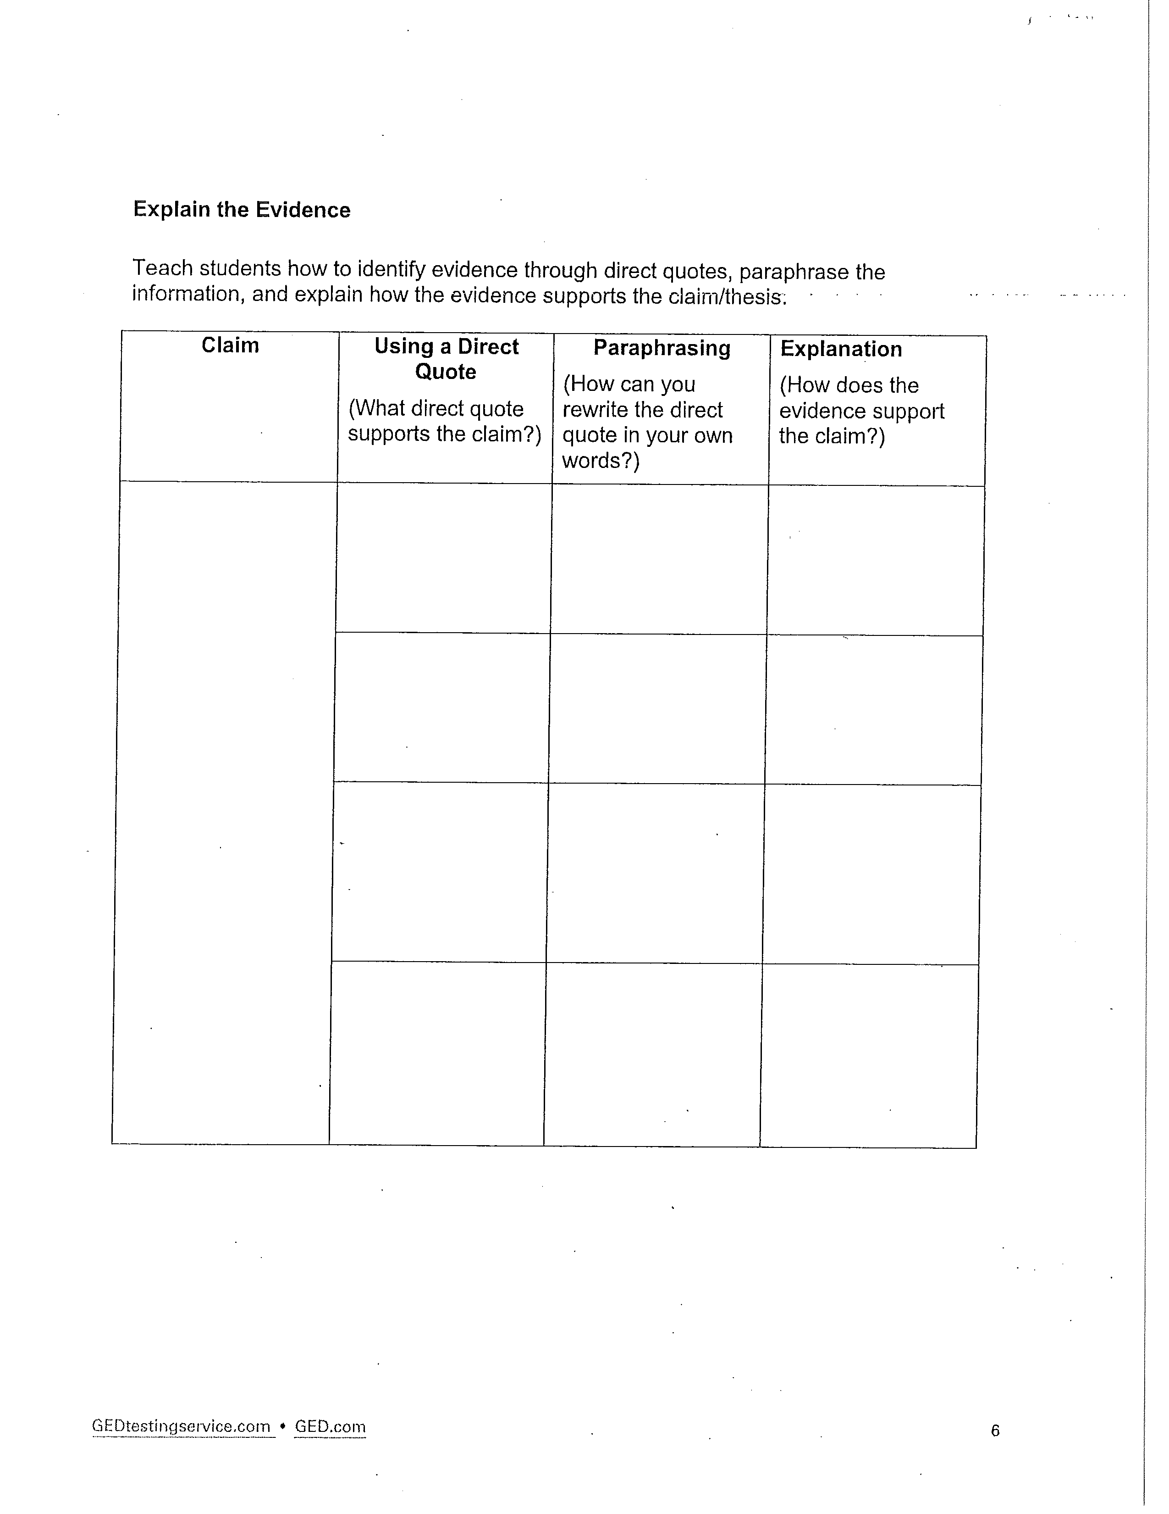

Essay Editing Checklist

Name Class Date

Title of Essay

Directions: Use this checklist to edit your finished work. Put a check ('1) in the box next to each item after you have checked, and if necessary corrected, errors in your work.

f  : Writing Element | What to Check For | Checked and Corrected
Sentence Structure | Sentences are complete.
Sentence Structure | Sentences vary in length.
Sentence Structure | Sentences vary in style.
Text Organization | The text has three pa rts: an introduction, a body, and a conclusion.
Text Organization | The introduction presents the main idea.
Text Organization | Each paragraph i n the body is directly relevant nt to the main idea.
Text Organization | Details are directly relevant nt to the ma i n idea.
Text Organization | The conclusion restates the ma in idea.
Punctuation | All sentences end with appropriate pu nctuation.
Punctuation | Quotation ma rks and commas are used correctly.
Capitalization | All sentences begin with a ca pita l letter.
Capitalization | All proper nou ns are capita lized.
Grammar | Each sentence has subject/verb agreement.
Grammar | There are no run-on sentences.
Spelling | All words are spelled correctly.

.c
O>
-

3

Writing Rubric

Name __________________________ Class _____________________________ Date ______________



